1. Project Overview

The application we are developing is an iOS application for the restaurant Simply Siam as per the client requirement

1.1 Objective

Customers of Simply Siam restaurant should be able to order there meal online.

1.2 Business Case

Both Simply Siam restaurant customer and owner have profit, customer can order online, and Simply Siam restaurant get more and new customers.

1.3 Risks

Document have specific risks that are Need to check the view controller and its implementation and when we are changing the version there is lot of changes that has to be checked.

1.4 Out of Scope

Implementing the payment online is out of our scope we have not implemented this.

2. Technical Design Diagram

It Provide a diagram that illustrates all new and existing technical resources required for the successful completion of this project.

* Network – assume all have internet and owner is fitted with leased line connection so that owner will not miss any customer orders.

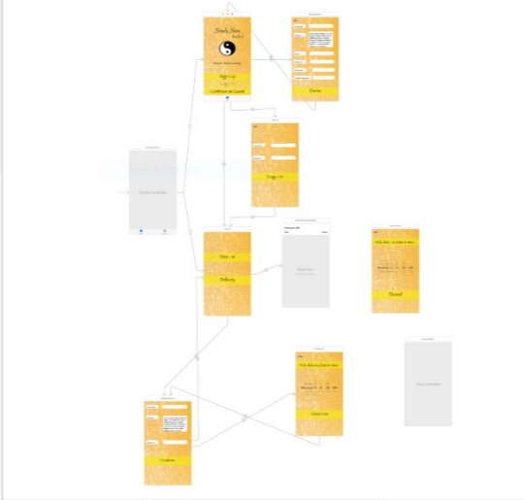

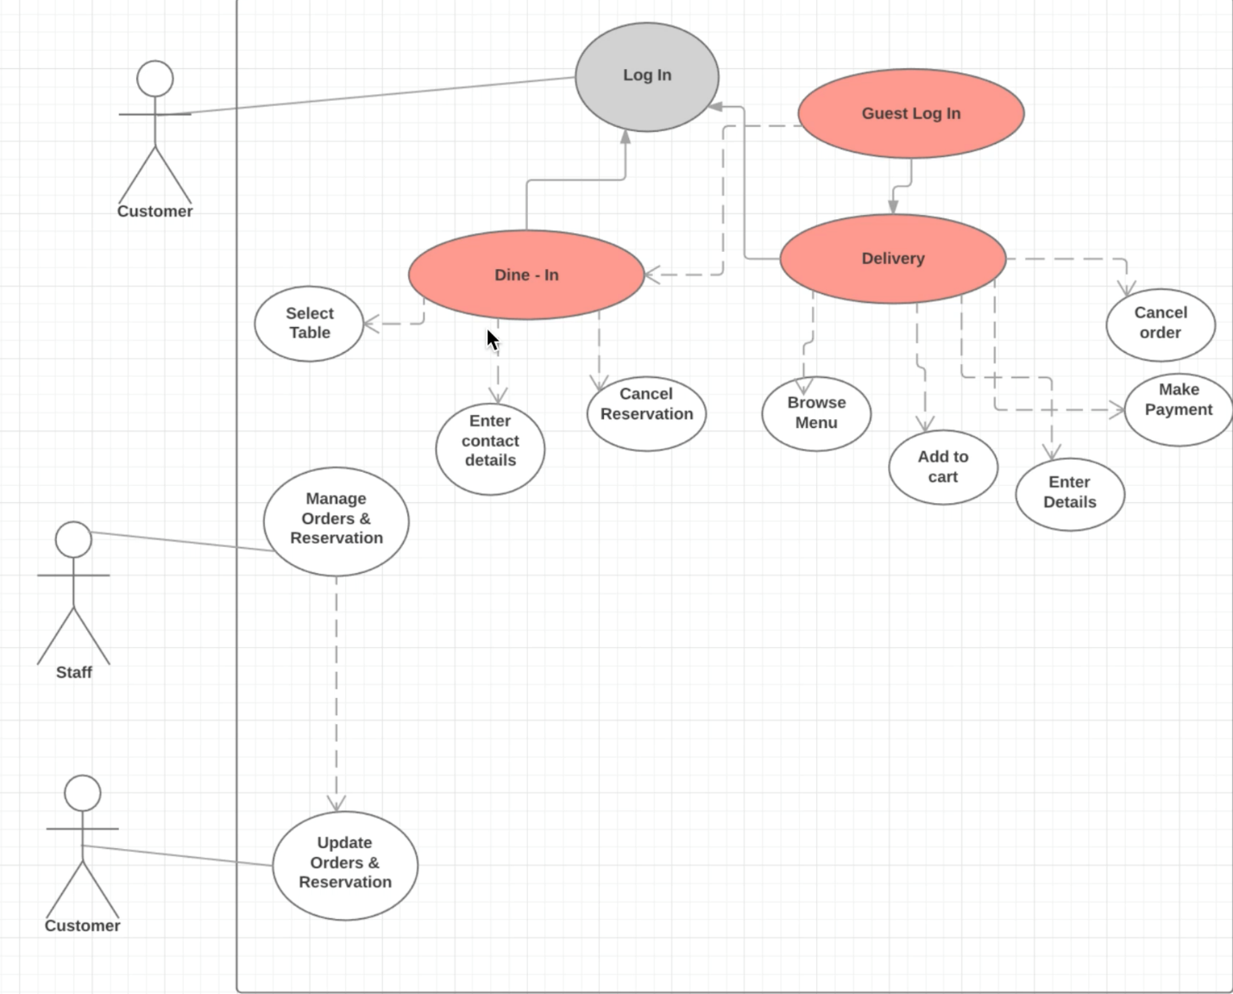

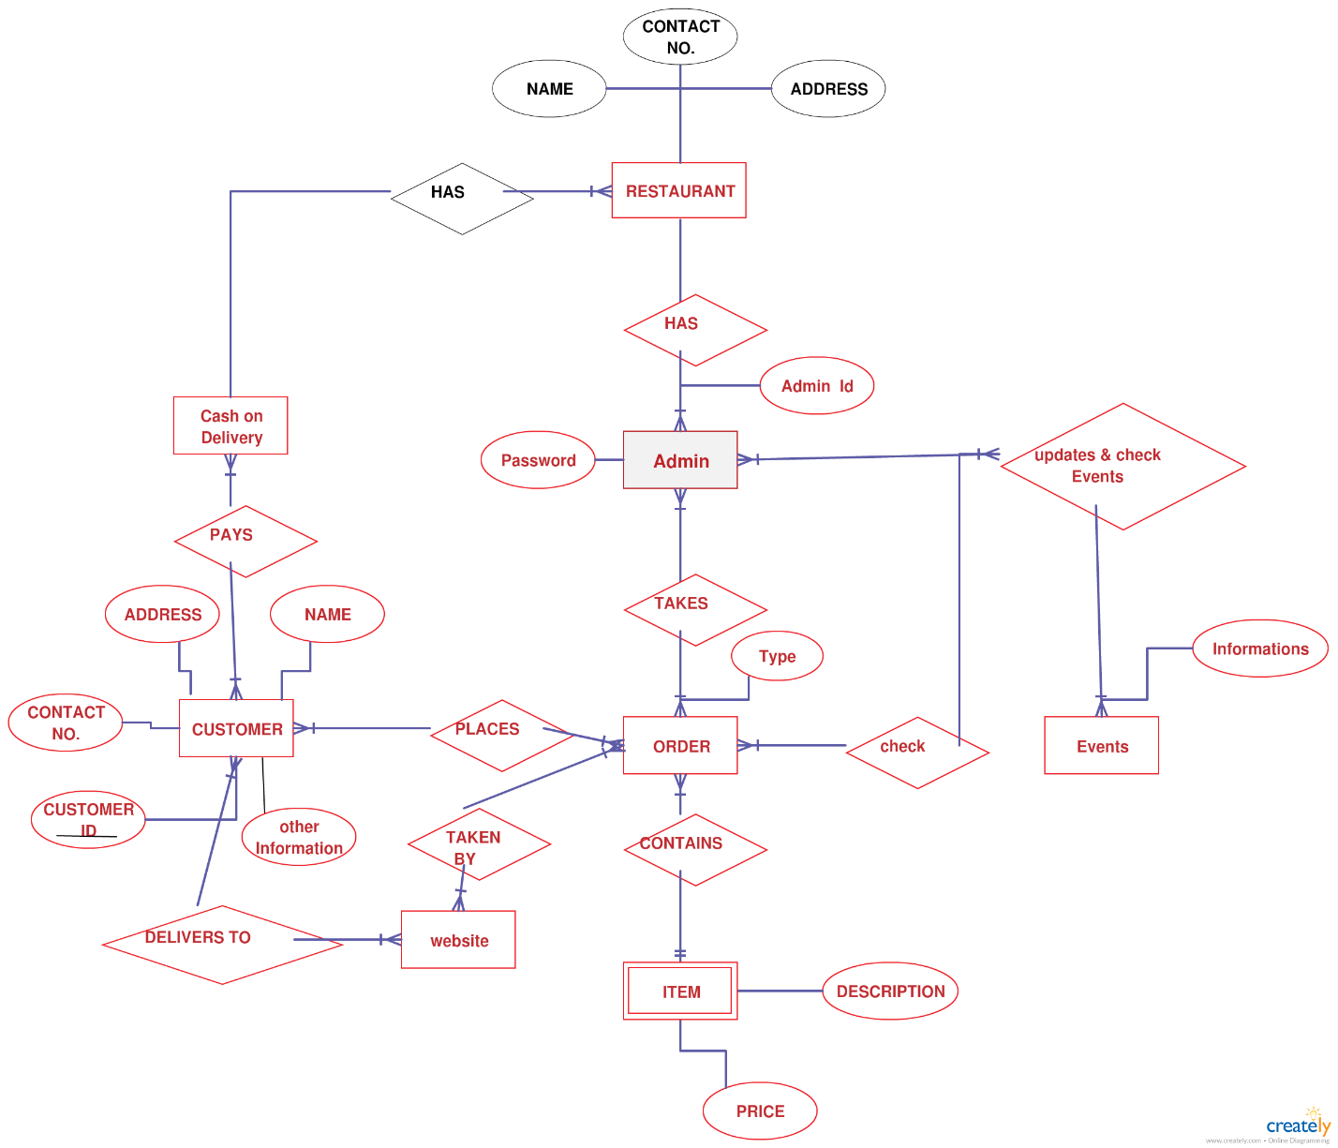

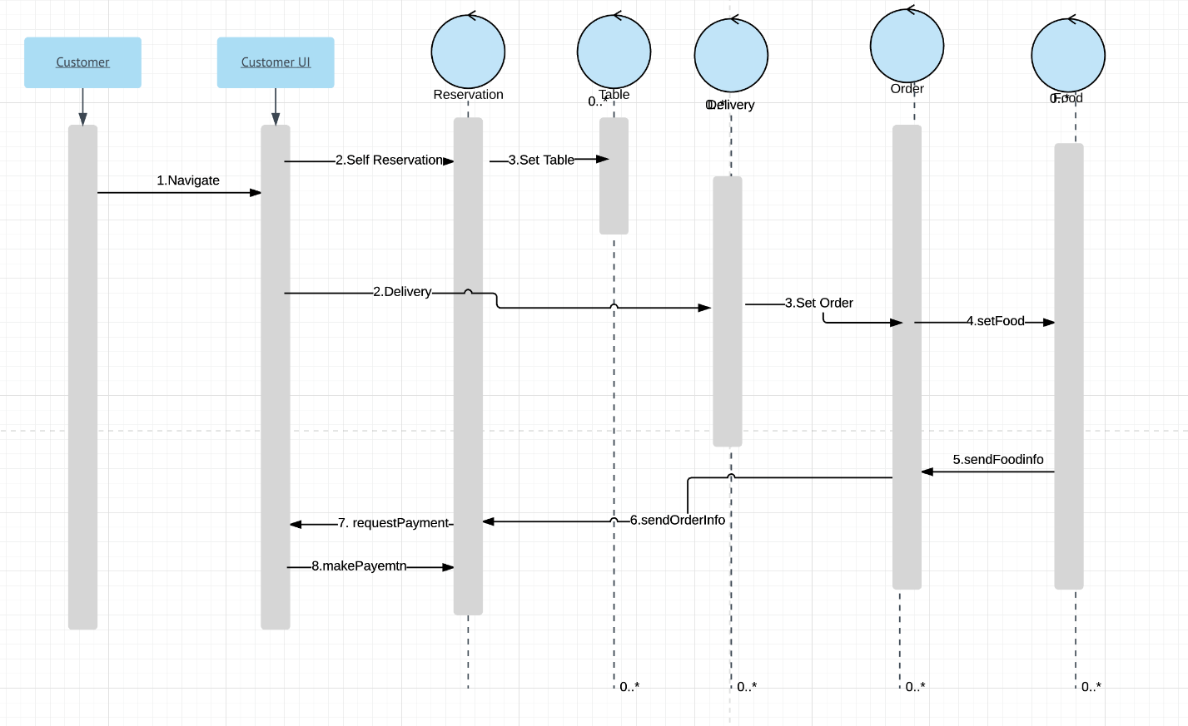

**3. Technical Specifications**

It Provide detailed technical specifications for required infrastructure as outlined below.

3.1 Servers

* Operating System is not a requirement because we are running our server in backendless application.
* Application memory requirements is one of the important part of our application because we need to store the customer details and there address to deliver the food.
* Application CPU requirements is minimal since during normal business hours, during holidays and festivals there will be lot of orders and lot of CPU utilization.
* Functional characteristics of the application is online order internet is the main dependency in the application and internet application
* Expected application transaction volume is 100 transaction per day

3.1.1 Application Servers

We are using backendless as our application server.

3.1.2 File Servers

We are not using and file server.

3.1.3 Web Servers

We are using Backendless as our web Server.

3.1.4 Database Servers

We are using Backendless for our database server

3.2 Server Request Forms

***Data Center Application and Equipment Hosting Services*** policy. No data is deleted without owner permission**.**

**3.3 Access Requirements**

Define the access requirements related to the following:

* Number ofusers requiring simultaneous access to the application is owner and multiple users.
* List user communities who will need access, including
  + Admin Developers
  + Departmental / Simply Siam restaurant(owners)
  + Vendors(delivery contractors)

**3.4 Databases**

List a brief description and function for each database that is needed, and include the following information:

* Database version is one
* Memory requirements high during weather fluctuation
* CPU requirements is normal
* Amount of storage needed the first 12 months is 50 gb
* Projected annual growth (10%)
* Expected transaction volume is 100 transaction per day
* Special data preservation like admin data

**3.5 Storage Needs exclusive of databases**

Describe the following elements related to storage needs, excluding database requirements:

* The amount of storage needed for the first 12 months is 50 GB).
* Projected annual growth 10%
* Data protection is absolutely necessary because we are saving customer phone number and address hackers can use it to malicious activities.

4. Resource Needs

Identify the staff resources needed to successfully complete this project. Also identify the staff, technical, and other resource dependencies that should be considered.

* Staff Resources in the restaurant who can understand orders in the application.
* Staff Dependencies to maintain and application errors and orders issue.
* Technical Dependencies is to keep server and internet up and working fine.

5. Assumptions

Assuming all the internet connection is maintained and server is updates as per monthly basis.

6. Concerns and Issues

As the time evolve we need to take paid storage and need to maintain reliable server.

**7. Projected Costs**

Considering 10 software developer with proper skill who is worth paying $60 an hour, Project can be completed in 85 hours this is just human resource.

We need to take proper internet connection of worth $150 a month.

We even need to consider support team who will maintain the service up and working fine

Project roughly cost $51000 initially, moving forward we need to calculate maintenance cost.

**Document Tracking**

The following chart is used to log of all changes made to this document.

| **Version** | **Date of edit/change** | **Who made the edit/change** | **Description of edit/change** |
| --- | --- | --- | --- |
| 9-18-2017 | Version – 1 | Snigda,Nikhil M | First software requirement specification |
| 10-01-2017 | Version – 2 | Lohita,Darshan | Design and analysis requirement specification |
| 10-01-2017 | Version – 3 | Nikhil K,Samyuktha  Neelesh | ER diagram, Design Constraints. |
|  |  |  |  |
|  |  |  |  |